Figure 1.

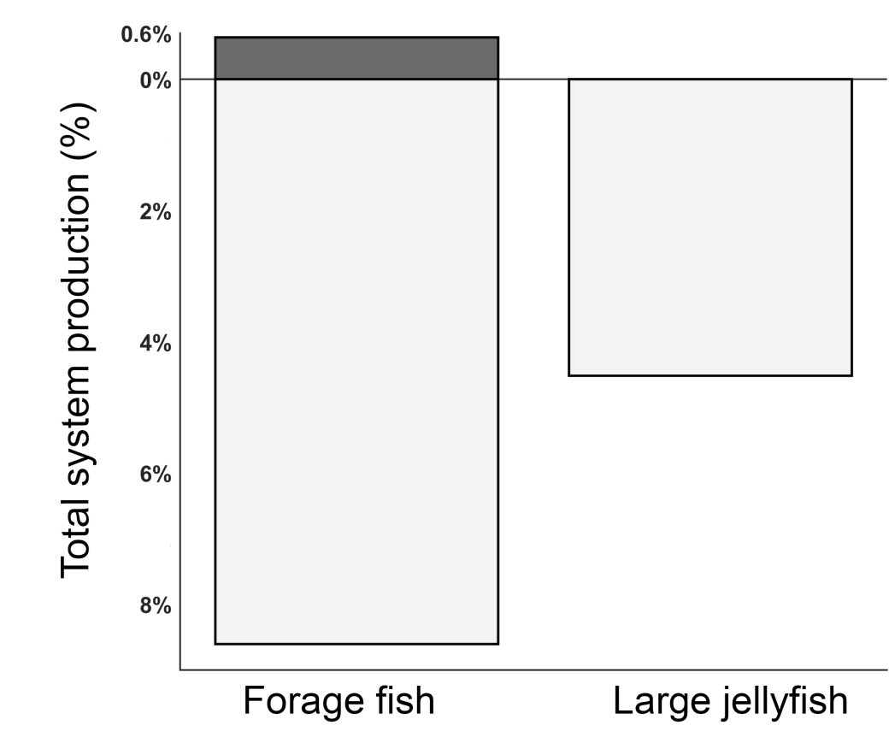

Figure 2

Figure 3

Figure 4
Table 1
Table 2
Code | Aggregated Functional Group | Scenario I | Scenario II | Scenario III | Scenario IV
1 | NO3 | - | - | - | -
2 | Pelagic NH4 | -1.1 (0.7) | 0.9 (0.9) | -0.8 (0.8) | 1.2 (0.9)
3 | Benthic NH4 | 3.0 (1.6) | -4.5 (1.9) | 3.7 (1.6) | -3.7 (1.7)
4 | Large phytoplankton | - | - | - | -
5 | Small phytoplankton | - | - | - | -
6 | Microzooplankton | 0.1 (0.05) | -1.8 (1.2) | 1.4 (1.0) | -1.6 (1.1)
7 | Mesozooplankton | - | -1.9 (1.5) | 1.5 (1.2) | -1.7 (1.3)
8 | Macrozooplankton | 0.01 (0.01) | -1.9 (1.7) | 1.5 (1.2) | -1.8 (1.5)
9 | Small jellyfish | -28.9 (22.5) | -49.9 (26.7) | 47.1 (34.9) | -45.7 (24.9)
10 | Large jellyfish | 38.5 (6.7) | -28.9 (16.5) | 24.0 (15.3) | -26.2 (14.8)
11 | Macrobenthos | 0.9 (0.6) | -0.4 (1.0) | 0.3 (0.8) | -0.1 (0.9)
12 | Forage fish | -12.4 (7.8) | 46.3 (4.5) | -38.7 (0.4) | 40.0 (3.1)
13 | Mesopelagic fish | -14.1 (11.1) | -56.3 (26.9) | 52.3 (32.3) | -51.5 (24.9)
14 | Cephalopods | -11.4 (8.6) | -49.8 (26.4) | 47.1 (34.7) | -34.1 (28.3)
15 | Pelagic planktivorous fish | -20.2 (18.9) | -30.5 (22.4) | 27.9 (25.4) | -18.9 (23.2)
16 | Pelagic piscivorous fish | -14.0 (9.5) | -2.6 (17.4) | 1.7 (17.3) | -24.4 (20.1)
17 | Demersal piscivorous fish | -12.9 (8.7) | -6.9 (18.1) | 5.2 (18.5) | 48.1 (36.2)
18 | Demersal planktivorous fish | -12.8 (13.0) | -22.5 (14.6) | 20.9 (18.4) | -20.6 (13.6)
19 | Demersal benthivorous fish | -10.4 (6.8) | -2.7 (18.8) | 1.8 (20.8) | 41.7 (40.7)
20 | Apex predatory fish | -12.4 (7.9) | -3.3 (20.1) | 2.1 (21.8) | 297 (300)
21 | Seabirds | -13.7 (9.2) | 30.9 (15.2) | -30.3 (15.1) | 31.6 (30.1)
22 | Marine mammals | -12.4 (8.2) | 1.7 (16.4) | -2.8 (17.1) | 66.3 (43.1)
23 | Sea turtles | 25.2 (14.5) | -31.8 (16.5) | 27.7 (17.9) | -73.4 (21.4)
24 | Eggs | -12.4 (7.8) | 46.3 (4.5) | -44.4 (4.5) | 41.8 (23.2)
25 | Detritus offal | -13.1 (8.0) | 30.7 (10.2) | -2.7 (4.6) | -100 (0)
26 | Fisheries | -13.1 (8.0) | 30.7 (10.2) | -2.7 (4.6) | -100 (0)
27 | Pelagic detritus | 0.05 (0.05) | -1.7 (1.2) | 1.3 (0.9) | -1.5 (1.1)
28 | Benthic detritus | 0.9 (0.6) | -0.4 (1.0) | 0.3 (0.8) | -0.01 (0.9)

